AWS Static Website Project

# Hosting a Static website on AWS:

# Problem Statement:

-A client wants me to host his school website (The information is hard coded and I have access to the code file) on AWS.

# Requirements:

-The website should be accessible with a domain name

-The website should be available globally and load fast

-The customer wants a cost-effective but efficient solution

-Also, the website should be secured with HTTPS.

# Solution Statement:

- I'll create an Amazon S3 bucket to hold the static website files and an Amazon CloudFront distribution to serve the website globally. Amazon Route 53 will manage the website domain name, and AWS Certificate Manager to provide a valid SSL/TLS certificate while making sure I am still within the customer's budget.

# Services for the project:

-Amazon S3

-Amazon CloudFront

-Amazon Route 53

-AWS Certificate Manager

# Creating an S3 bucket for the source code

-The bucket for the website

-Now, that I am done uploading all the files for the website to an S3 bucket. Let's make the files public so that anyone can access them with a link, and I need to create an IAM policy too.

# Editing the S3 bucket’s public access permissions, also edit the Bucket policy permission too for the IAM policy

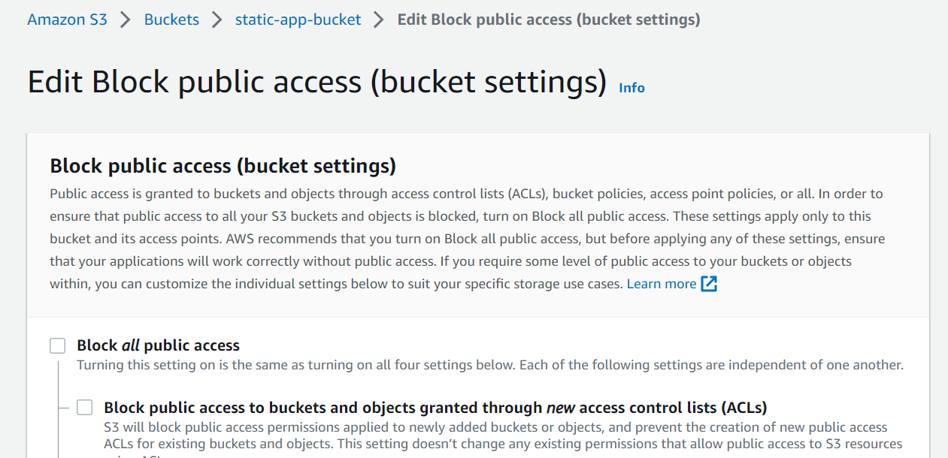

-Let see configure the S3 bucket so we can access the static website. But first, we need to specify the default and error page of our website from the S3 Bucket’s Properties tab under the Static website hosting section.

# The website URL is below the static website hosting: Click on it and see if it works.

-Let’s configure CloudFront to serve our content globally. Creating a Distribution in CloudFront.

# The Distribution of the website

# Using the distribution name to access the website

-Now, I need to set a custom domain name with Route 53.

# Creating a Route 53 hosted zone for the application.

# DNS records in the hosted zone.

# Configuring name servers on the domain host company website

# Adding alternative domain name on CloudFront.

# Requesting a certificate for the website.

# Setting records in Route 53 to direct traffic to CloudFront

# Hosted DNS record

# Accessing the website using a registered custom website



-Now the website is secure and hosted on AWS.